4.1 The wave function for a hydrogen atom is given by
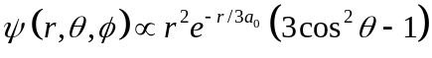
a) What are the quantum numbers 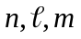 for this atom? No calculations allowed.
b) What is the most probable value of r for the electron in this state? What is significant about the result?
Solution:
a) The n quantum numbers is 3 because the denominator in the exponential in the radial parts of the wave functions is 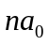. The function 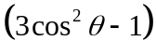 is proportional to 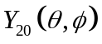. Note that there is no φ dependence which confirms that 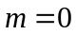. Answer: 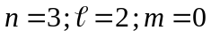
b) The most probable value of r is the position of the maximum in the probability distribution 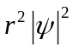. The max will be the same as the max of 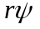so, taking the derivative with respect to r: and setting it equal to zero:
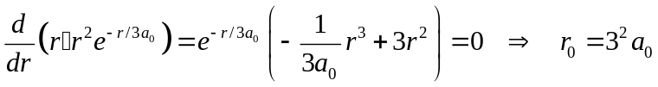
This is the third Bohr radius. It turns out that for the state of maximum  for a given n the most probable value of r is always the Bohr radius.

4.2 The wave function for a hydrogen atom is given by
For what values of  and m (= m) will ψ be an eigenfunction of the Hamiltonian? What is the energy in electron volts? in Rydbergs? in au? in cm⁻¹?
Solution:
Since the radial parts of the wave function all have n = 5, 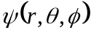 is already an eigenfunction of the Hamiltonian. Recall that the energy for a hydrogen atom doesn't depend on either  or m .
Therefore the only requirements on  or m are that they be consistent with n = 5 and, of course, each other.
Since the radial part of the first term has  = 4, so too must the spherical harmonic.
Further, m must be such that –4 ≤ m ≤ +4.

The energy for n = 5 is:

4.3 An electron is in the ground state of tritium, i.e a hydrogen atom with two neutrons the symbol for which is ³H. A nuclear reaction instantaneously changes the nucleus to ³He which retains the single electron from the tritium atom. That is, the product is a singly ionized ³He which is a one-electron atom. Calculate the probability that the atomic electron remains in the ground state of the ³He ion.
Solution:
We may expand the wave function for the "old" atom, the tritium, on the complete set of eigenfunctions of the Hamiltonian for the "new" one-electron atom, the ³He⁺.
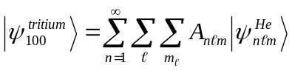
But, we are only interested in the probability that the ³He is in the ground state so we need only A₁₀₀ because the desired probability is | A₁₀₀ |². Furthermore, the spherical harmonics will be the same in the new and old wave functions. In fact, 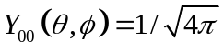 so when we integrate the square of Y₀₀ over all angles we get 1. Therefore, we need only work with the radial parts of the two wave functions. These wave functions are identical except that the tritium wave functions have Z = 1 while the He wave functions have Z = 2.
Formally, we take the inner product 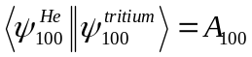
Now we must perform the integral in coordinate space. The wave functions are
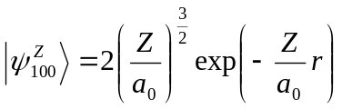
so that
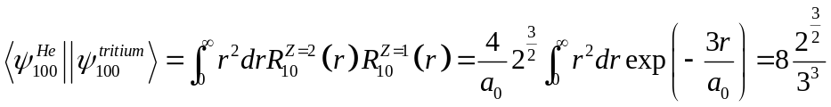
and 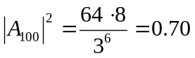

4.4 An electron in the Coulomb field of a proton is described by the normalized wave function
where the 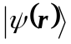 are spherical (orbital) eigenfunctions of the hydrogen atom Hamiltonian.
Find:
a) The expectation value of the energy in a.u.
b) The expectation value of 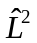. Keep the 's in the answer.
c) The expectation value of 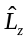.
Solution:
a)
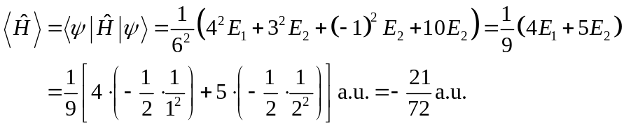
b)

c)
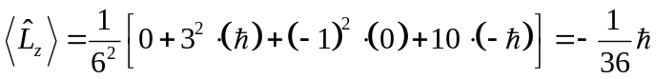

4.5 A hydrogen atom is in an eigenstate of 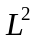 and 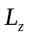. Show that, although neither 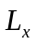 nor 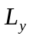 are well defined, their sum 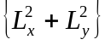 is well defined. Find the value of in terms of  and 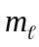. Ignore spin.
Solution:
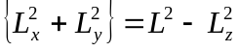
Therefore
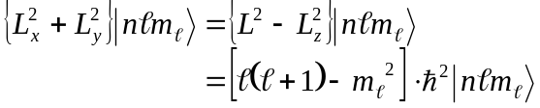
which does indeed have a definite value.

4.6 Show that the integrals
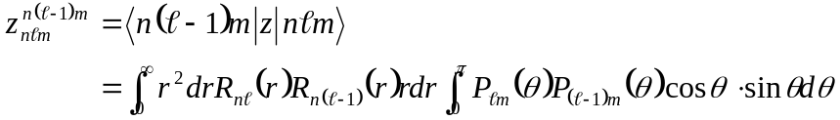
and
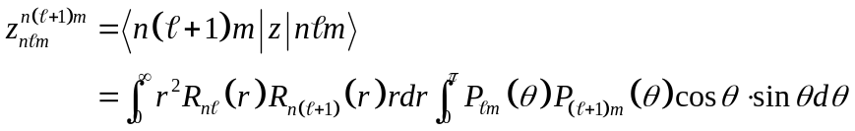
are given in atomic units by
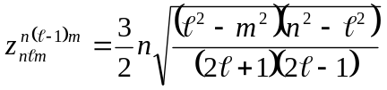
and
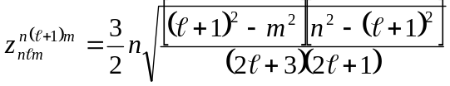
Solution:
To evaluate the θ-integral use the following relation for associated Legendre functions:
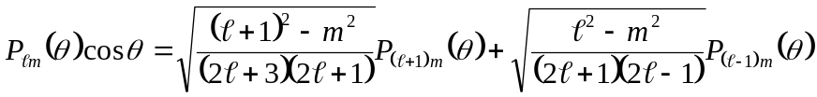
and the orthogonality relation 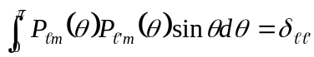. Evaluate the r-integral using
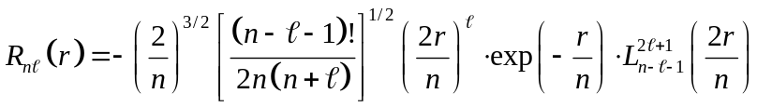
and the recursion relation for associated Laguerre functions
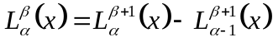
which is applicable only to the associated Laguerre polynomials as defined in the radial wave function given above, i.e. Definition 2. You will also need the orthogonality relation
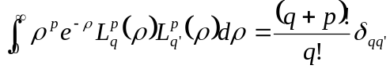
By letting 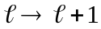 obtain 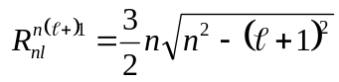.
Solution:
The θ-integral:
Replace 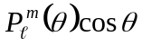 with the identity given. For 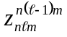 the only term that survives is the one with 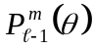. Therefore
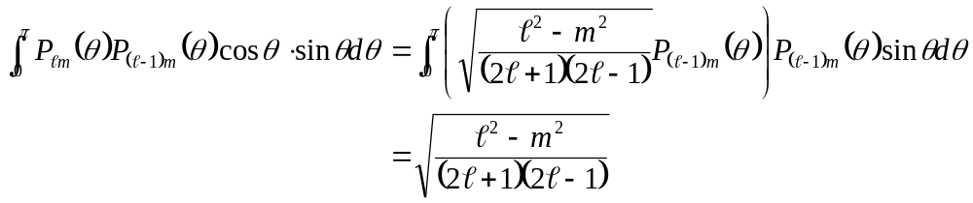
For 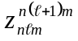 the only term that survives is the one with 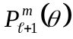. Therefore
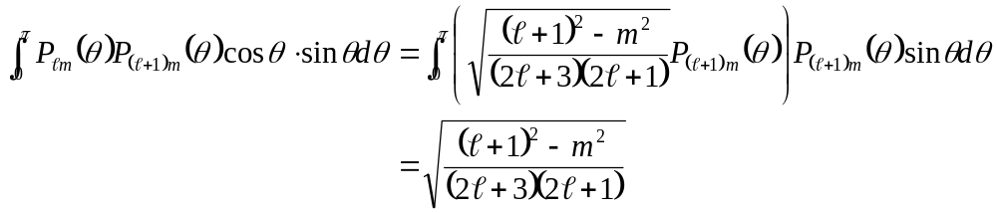
The r-integral:
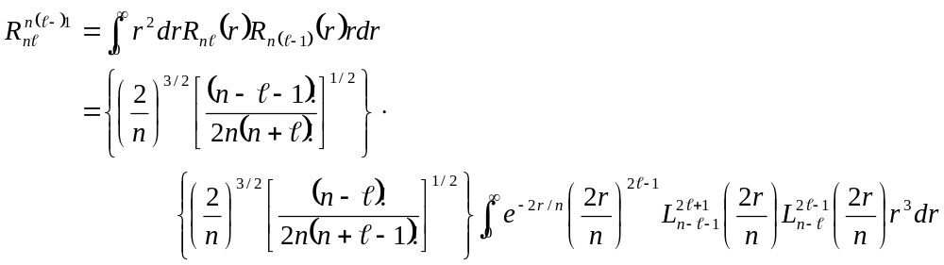
Now let 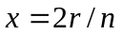 so 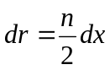. We get
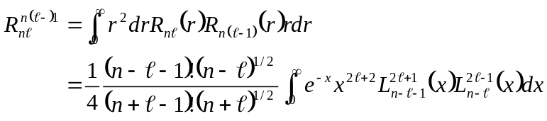
To use the orthogonality integral we must use the recursion relation to raise the upper index to match the power of x, i.e. to 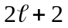.
In the recursion relation we identify 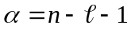 and 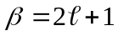 in the first associated Laguerre function under the integral.
We have then 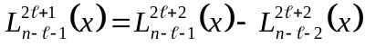
Now we have to do the same thing with the second Laguerre function. 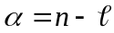 and 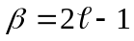. Therefore,
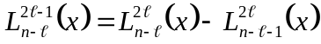
Clearly the recursion relation must be applied twice more.
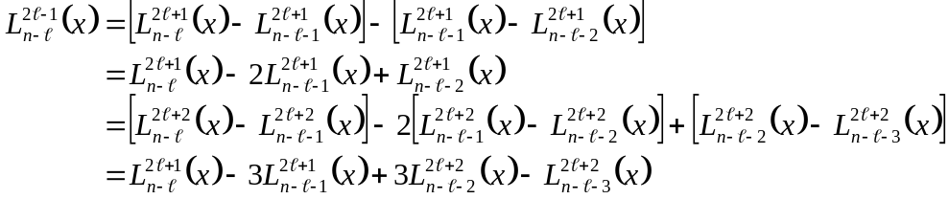
Now, in order for the integral to be non-zero we must have both associated Laguerre polynomials the same. Therefore, the only terms in the product that will be non-zero are
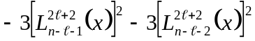
We have then
and using
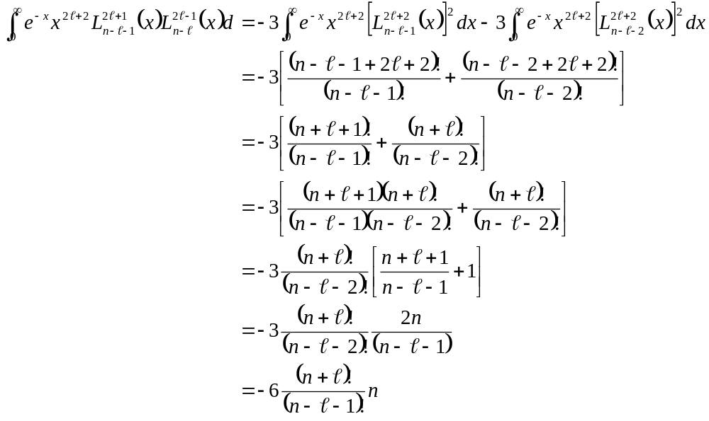
We have then
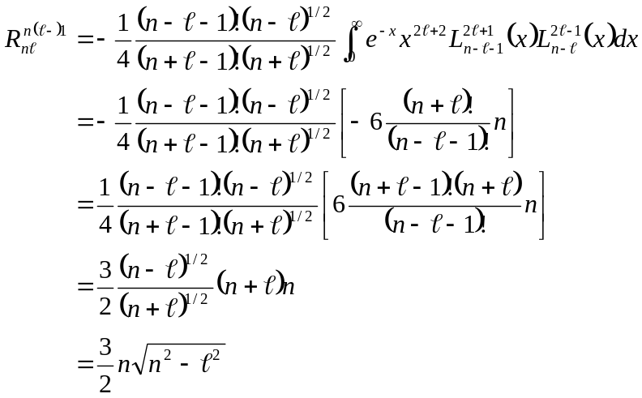
If we let we obtain 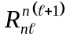
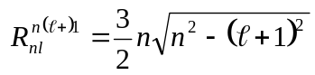
We have then
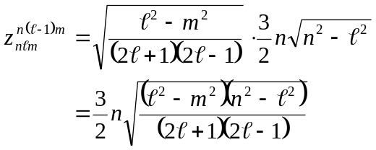
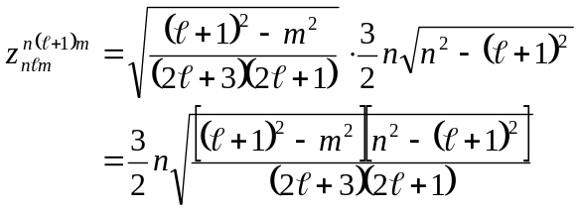

4.7 A collection of hydrogen atoms is in a parabolic eigenstate 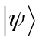 given by
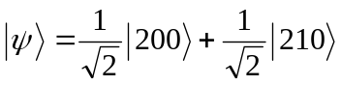
where the kets on the right are the spherical eigenkets 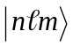.
a) What is the energy eigenvalue, in atomic units, corresponding to ?
b) What are the possible sets of parabolic quantum numbers that characterize ? Virtually no computation is required. Merely list the combinations that are possible from inspection of the wave function given.
Solution:
a) Since n = 2 the eigenvalue is:
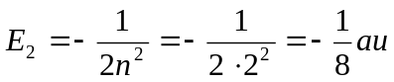

b) The parabolic quantum numbers n, n₁, n₂, m are related by:
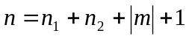
Since n = 2 and m = 0 (from the wave function above), we must have
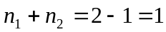
Since n₁ and n₂ can take on only integral values, the possible combinations for parabolic quantum numbers are:
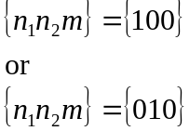

4.8 The normalized energy eigenfunctions for the hydrogen atom in parabolic coordinates are given by
where 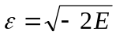 and the L's are associated Laguerre polynomials.
a) Find the normalized hydrogen atom energy eigenfunctions in parabolic coordinates for n = 2, n1 = 1, n2 = 0 = m in terms of the hydrogen atom energy eigenfunctions in spherical coordinates.
b) - h) What are the probabilities of measuring the following:
b) the energy of the ground state.
c) the energy of the first excited state.
d) total angular momentum zero
e) total angular momentum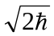.
f) z-component of angular momentum zero.
g) z-component of angular momentum .
h) Find the normalized ground state eigenfunction in parabolic coordinates in terms of the spherical eigenfunctions. What is noteworthy about this eigenfunction and why?
Solution:
a)
but 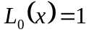 and 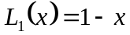 so that
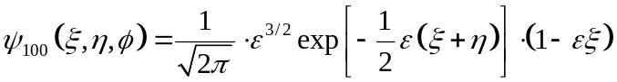
The defining relations for parabolic coordinates are
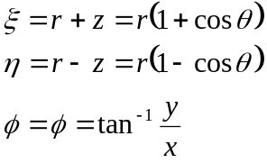
from which we find
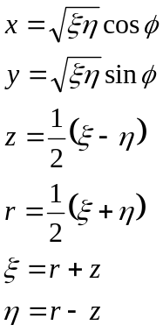
Also, 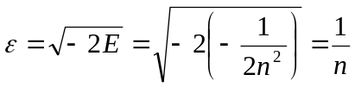 which in this case is ε = 1/2 because n =2.
We have then
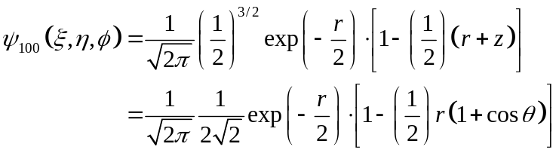
Now 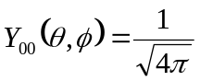 and 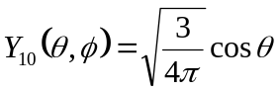 while 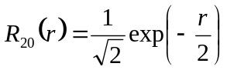 and
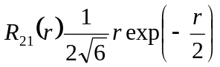 so that we can rewrite u100 in a more transparent way.
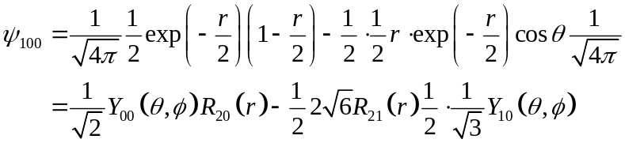
or 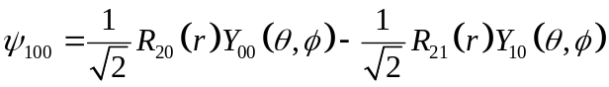
b) The energy depends only on the radial part of the wavefunction, 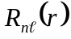. Since the only principal quantum number that appears in 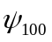 is n = 2, the probability of measuring E₁, the ground state energy is zero.
c) n = 2 corresponds to the first excited state energy so that the probability of measuring E₂ is unity.
d) The total angular momentum is given by 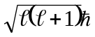 where  appears in the spherical harmonic 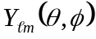. Therefore, the probability of measuring  = 0 is given by the square of the coefficient of the spherical harmonic that contains  = 0, i.e. 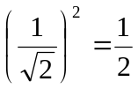
e) Probability of  =1: 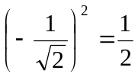
f) Since both spherical harmonics in have m = 0 the probability of measuring m = 0 is unity.
A better way of saying this is that m is a good quantum number in both spherical and parabolic coordinates and m = 0 for this parabolic eigenstate.
g) In view of f) the answer is zero.
h) Parabolic quantum numbers for the ground state are: n = 1, n₁ = n₂ = m = 0. From the expression given for the wavefunction in parabolic coordinates we have
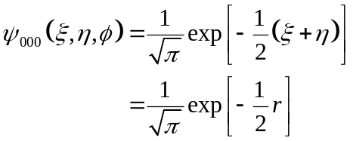

To convert this to spherical coordinates we use Equations (5.1)
Adding the first two together we get 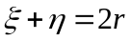 so in spherical coordinates this wave function is
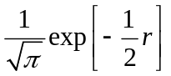 which is 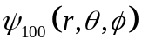. Thus, the ground state parabolic wave function and the ground state spherical eigenfunctions are the same. The reason these wave functions are the same is that the ground state is non-degenerate.

4.9 A hydrogen atom is in an eigenstate that is characterized by the parabolic quantum numbers
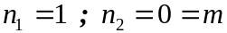. The wave function in spherical coordinates in atomic units is:
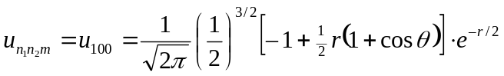
That is, you have been spared the trouble of writing the wave function in parabolic coordinates and converting to spherical coordinates. Some selected spherical harmonics and radial hydrogen atom wave functions are:
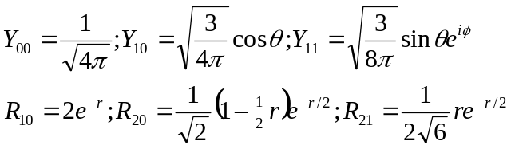
a) If a measurement of the energy of the atom in this state is made what are the possible values of the energy that could be measured? Give your answer in atomic units. What probabilities are associated with each value?
b) If a measurement of the total orbital angular momentum of the atom in this state is made what are the possible values that could be measured? What probabilities are associated with each possible angular momentum?
c) If a measurement of the z-component of the angular momentum of the atom in this state is made what are the possible values that could be measured? What probabilities are associated with each possible z-component ?
Solution:
a) Since we have . Therefore, the eigenstate is characterized by n = 2 and the only possible result of the measurement is 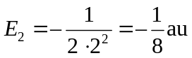
b) This is the only part that requires any calculation. We must cast 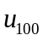 u₁₁₀ in terms of the spherical harmonics and the radial wave functions. From the spherical harmonics and radial wave functions given, we have:
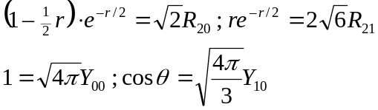
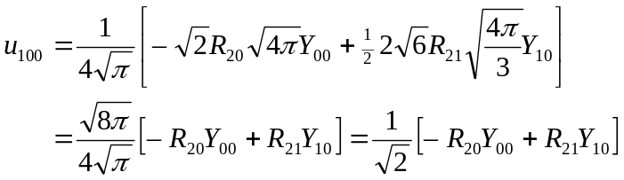
From the last form we see that  = 1 and 0 are possible. Since the expansion coefficients are the same, these values are equally probable.
c) The system is in an eigenstate of L_{z}, i.e m = 0. Therefore, the only possible value of the z-compontent of angular momentum that could be measured is 0. This is also clear from the last form of the wave function since both spherical harmonics have m = 0.

4.10 Show that the expectation value of the electric dipole moment of an atom having N electrons in a state of well-defined parity vanishes. Use atomic units. Suppose a hydrogen atom is in a spherical eigenstate. What is the dipole moment? How about a parabolic eigenstate?
Solution:
The dipole moment is given by
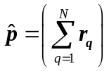
so the expectation value of the dipole moment is
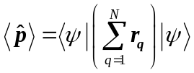
where, of course, the integral on the rhs is over all space.
Since 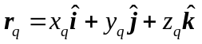 the dipole operator has definite parity – odd. If the state vector 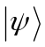 has definite parity as specified in the statement of the problem, then the integrand on the rhs vanishes because the product 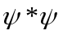 is necessarily even.
Spherical eigenstates have definite parity so a hydrogen atom in a spherical eigenstate has no dipole moment. Parabolic eigenstates do not necessarily have definite parity so a hydrogen atom in such an eigenstate can have a permanent dipole moment. Of course, those states for which the spherical and parabolic eigenfunctions are the same cannot have dipole moments.

